**Simulator Flow Guide**



# Intro

Welcome to the Simulator Flow Guide. This guide is designed to help organize your content to ensure that LemonadeLXP staff can create a simulation of your app or website that looks and feels like the real thing!

## How To Use This Document

In the second half of this document you will find empty templates for you to outline all the potential paths that a user can take.

Each page of the template is a description of one of your images (or screens). It describes what users are able to select on that given screen, and where they will be taken by selecting.

To ensure that the simulation mimics the real app or webpage, please provide direction for every possible hotspot on each screen.

## Filling out the template

**Images**

* Images are to be included in a separate folder. Images that are embedded in this document cannot be used in the creation of the simulator
* Be sure that the image file names provided in this document match the file names in the external folder
* Each image should have it’s own unique name or identifier

Having images that are the right size and format make a big difference! For help as to how to best create images to be used in your simulator, please see these articles:

* [**Images and flow guide**](http://academy.launchfire.com/en/articles/4723959-demo-step-images-and-flow-guide)
* [**Image sizing**](http://academy.launchfire.com/en/articles/3340193-for-stepdemo-what-image-size-should-i-be-uploading)

**Hotspots**

* It’s best to include small screen-grabs of the areas of your screen which you wish to make hotspots
* Be sure to include all hotspots on each screen. If a hotspot is not outlined with a destination, it will not be included
* Images of hotspots can be embedded here, as the image is just for reference

**Leads to:**

* This is the hotspot’s destination
* Please provide the image file’s name, as seen in the external folder you provide

❌ Bad Example

Screen 1 - Accounts

|  |  |
| --- | --- |
| **Image File** | **Accounts** |

|  |  |
| --- | --- |
| **Hotspot** | **Leads to** |
| Deposits (section the check) | Deposits screen |
| Payments (section the arrows) | Payments screen |

✅ Good Example

Screen 1 - Accounts

|  |  |
| --- | --- |
| **Image File** | **Accounts.jpg** |

|  |  |
| --- | --- |
| **Hotspot** | **Leads to** |
|  | Deposits.jpg |
|  | Payments.jpg |

# Examples of Completed Templates

|  |  |
| --- | --- |
| **Step Info** | |
| **Item** | **Your Info** |
| **Step Title** | Navigate Deposits |
| **Complexity**How difficult is this step on a scale of 1-5? | 2 |
| **How many minutes will the step take to complete?** | 5 |
| **Description** What are people getting themselves into?!?! | Use this simulator to gain familiarity navigating the Deposits section of our mobile app in a risk-free environment! Click through the screens as you normally would the app. |
| **What players will learn** | Gain familiarity with deposits and the mobile app |
| **Skills** | Digitally Fluent |

## Screen 1 - Accounts

|  |  |
| --- | --- |
| **Image File** | **Accounts.jpg** |

|  |  |
| --- | --- |
| **Guiding Text** | |
| You’re on the Accounts screen. Click the Deposits icon below or explore another page. | |
| **Hotspot** | **Leads to** |
|  | Deposits.jpg |
|  | Payments.jpg |
|  | More.jpg |
|  | SignOut.jpg |
|  | Checking1.jpg |
|  | Checking2.jpg |

## Screen 2 - Deposits

|  |  |
| --- | --- |
| **Image File** | **Deposits.jpg** |

|  |  |
| --- | --- |
| **Guiding Text** | |
| You’re on the Deposits screen. Click on an icon to navigate where you would like to go. | |
| **Hotspot** | **Leads to** |
|  | Payments.jpg |
|  | More.jpg |
|  | SignOut.jpg |
|  | DepositCheck.jpg |
|  | MobileDepositHistory.jpg |

|  |  |
| --- | --- |
| **Exit Summary Text** | |
| Hopefully you’re getting a hang of the mobile app now! Feel free to use this simulator any time. | |
| **Completion Action** | |
| **Link Text** | Learn more |
| **Link URL** | https://www.lemonadelxptraining.com/learn |
| **Action Description** | Have more questions regarding the mobile app? |
| **Image**  (include in separate folder) | CompletionThumbnail.jpeg |

## Example Assets

These images are only to provide context for the examples Screen 1 and Screen 2.

These images are to be sent in a separate folder. Embedded images cannot be used in creating simulations.

Accounts.jpg Deposits.jpg

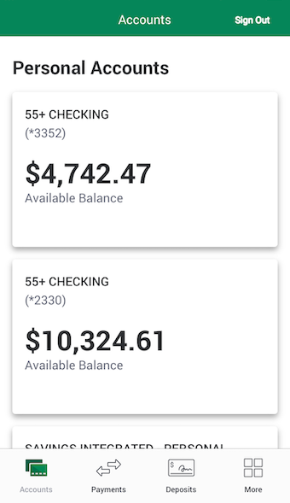 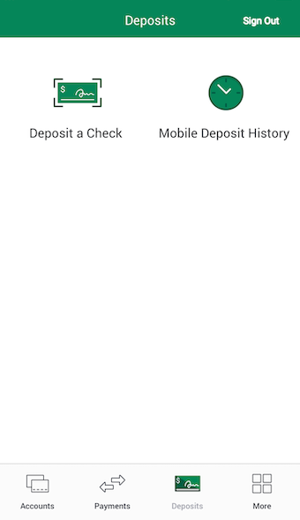

Complete your template guide on the following pages.

# 

# Your Template

### Start drafting your Simulator here!

|  |  |
| --- | --- |
| **Step Info** | |
| **Item** | **Your Info** |
| **Step Title** |  |
| **Complexity**How difficult is this step on a scale of 1-5? |  |
| **How many minutes will the step take to complete?** |  |
| **Description** What are people getting themselves into?!?! |  |
| **What players will learn** |  |
| **Skills** |  |

## Screen 1 -

|  |  |
| --- | --- |
| **Image File** |  |

|  |  |
| --- | --- |
| **Guiding Text** | |
|  | |
| **Hotspot** | **Leads to** |
|  |  |
|  |  |
|  |  |
|  |  |
|  |  |

*Paste as many screen templates as needed.*

|  |  |
| --- | --- |
| **Exit Summary Text** | |
|  | |
| **Completion Action** | |
| **Link Text** |  |
| **Link URL** |  |
| **Action Description** |  |
| **Image**  (include in separate folder) |  |