**Demo Template Guide**



**Table of Contents**

Intro

How To Use This Document

Filling Out the Template

Example of Completed Template

Step Info

Screen 1 - Accounts

Screen 2 - Deposits

Screen 3 - Mobile Deposit Main Page

Screen 4 - Account Selection

Screen 5 - Enter Amount

Example Assets Used

Your Demo (drafting section starts here)

# Intro

Welcome to the Demo Flow Guide. Before you’re ready to start drafting, you’ll need to collect some assets, primarily images!

This guide is designed to help organize your images and flow before you start creating a Demo in your instance of LemonadeLXP. There are several use cases for this, including:

* If you’re authoring a Demo:
  + Use this to help you assemble all of the necessary assets in planning your own Demo Step.
  + Send this to other teams and have them gather all necessary assets before creating your Demo Step.
* If you need to gather material for someone else to author:
  + Use this to assemble all the necessary assets before sending this off to a coworker to author.
  + Complete this document and send it over to a LemonadeLXP author and have us build your Demo.

## How To Use This Document

In the second half of this document you will find empty templates for you to outline your Demos path.

Each page of the template is a description of one of your images (or screens). It describes what users are able to select on that given screen (hotspots), and what will happen when a hotspot is selected.

To ensure that the Demo mimics the real app or webpage, please provide direction for every possible hotspot needed to complete Demo’s goal/path.

Also, it’s a good idea to give some of our help docs a read before starting to collect assets! We don’t want you to have to backtrack because images were the wrong size.

* **[Demo Step Images and Flow Guide](http://academy.launchfire.com/en/articles/4723959-demo-step-images-and-flow-guide)**
* **[How to Build a Demo Step](http://academy.launchfire.com/en/articles/2762400-how-to-build-a-demo-step)**
* **[What Image Size Should I Be Uploading?](http://academy.launchfire.com/en/articles/3340193-for-stepdemo-what-image-size-should-i-be-uploading)**

## Filling Out the Template

**Images**

* If you’re sending this template to others, images are to be included in a separate folder. Images that are embedded in this document cannot be used in the creation of the Demo
* Be sure that the image file names provided in this document match the file names in the external folder
* Each image should have it’s own unique name or identifier

Having images that are the right size and format make a big difference! For help as to how to best create images to be used in your Demo, please see these articles:

* **[Images and flow guide](http://academy.launchfire.com/en/articles/4723959-demo-step-images-and-flow-guide)**
* **[Image sizing](http://academy.launchfire.com/en/articles/3340193-for-stepdemo-what-image-size-should-i-be-uploading)**

**Hotspots**

* It’s best to include small screen-grabs of the areas of your screen which you wish to make hotspots
* Be sure to include all hotspots on each screen. If a hotspot is not outlined with a destination/action, it will not be included
* Images of hotspots can be embedded here, as the image is just for reference

**Actions (Directs to and Autotext):**

* This details what selecting the hotspot will do (write text, direct to ___screen)
* Be as specific as possible! If the action is writing text, write the desired text word for word. If the action is directing to a new screen, please provide the image file’s name of that screen, as seen in the external folder you provide.
* If the desired action is something like “adding a checkmark to *Remember me* box”, please provide screenshots of this box being checked off

❌ Bad Example

Screen 1

|  |  |
| --- | --- |
| **Image File** | **Accounts** |

|  |  |
| --- | --- |
| **Hotspot(s)**  (min. 1 required) | Deposits image at bottom |
| **Directs To** | Deposit screen |
| **Guiding Text**  (seen in Guided Practice mode) | Click on Deposits. |
| **Autotext**  (if applicable) |  |
| **Learn More Link Text** |  |
| **Learn More Description** |  |

## 

✅ Good Example

Screen 1 - Accounts

|  |  |
| --- | --- |
| **Image File** | **Accounts.jpg** |

|  |  |
| --- | --- |
| **Hotspot(s)**  (min. 1 required) | image2.png |
| **Directs To** | Deposits.jpg |
| **Guiding Text**  (seen in Guided Practice mode) | Click on Deposits. |
| **Autotext**  (if applicable) | N/A |
| **Learn More Link Text** | N/A |
| **Learn More Description** | N/A |

# Example of Completed Template

|  |  |
| --- | --- |
| **Step Info** | |
| **Item** | **Your Info** |
| **Step Title** | How to Complete a Mobile Deposit |
| **Complexity**How difficult is this step on a scale of 1-5? | 2 |
| **How many minutes will the step take to complete?** | 5 |
| **Description** What are people getting themselves into?!?! | Checks can easily be deposited on the go using the mobile app! This step will teach you how, in a risk free environment! |
| **What players will learn** | How to deposit a check using the mobile banking app |
| **Does this contribute to learner progress?** | Yes |
| **Skills** | Digitally Fluent |

|  |  |
| --- | --- |
| **Demo Goal**  (This isn’t a field within LemonadeLXP, but should be included in your draft) | Get from the accounts screen to the take a picture section of Mobile Deposit.  *Note: Normally you would want to create a demo that fully completes a goal (i.e., get from accounts screen to completion of a mobile deposit), but for the sake of brevity we won’t fully complete the goal here.* |

## Screen 1 - Accounts

|  |  |
| --- | --- |
| **Image File** | **Accounts.jpg** |

|  |  |
| --- | --- |
| **Hotspot(s)**  (min. 1 required) | image2.png |
| **Directs To** | Deposits.jpg |
| **Guiding Text**  (seen in Guided Practice mode) | Click on Deposits. |
| **Autotext**  (if applicable) | N/A |
| **Learn More Link Text**  (optional) | N/A |
| **Learn More Description**  (optional) | N/A |

## Screen 2 - Deposits

|  |  |
| --- | --- |
| **Image File** | **Deposits.jpg** |

|  |  |
| --- | --- |
| **Hotspot(s)**  (min. 1 required) | image5.png |
| **Directs To** | MDMainPage.jpg |
| **Guiding Text**  (seen in Guided Practice mode) | Click on Deposit a Check. |
| **Autotext**  (if applicable) | N/A |
| **Learn More Link Text**  (optional) | N/A |
| **Learn More Description**  (optional) | N/A |

## Screen 3 - Mobile Deposit Main Page

|  |  |
| --- | --- |
| **Image File** | **MDMainPage.jpg** |

|  |  |
| --- | --- |
| **Hotspot(s)**  (min. 1 required) | image8.png |
| **Directs To** | MDAccountSelection.jpg |
| **Guiding Text**  (seen in Guided Practice mode) | Change the deposit account from Checking to your Personal Savings account. |
| **Autotext**  (if applicable) | N/A |
| **Learn More Link Text**  (optional) | Which accounts are eligible? |
| **Learn More Description**  (optional) | All personal and small business checking and savings accounts are eligible for mobile deposit. |

## Screen 4 - Account Selection

|  |  |
| --- | --- |
| **Image File** | **MDAccountSelection.jpg** |

|  |  |
| --- | --- |
| **Hotspot(s)**  (min. 1 required) | image4.png |
| **Directs To** | MDMainPage2.jpg |
| **Guiding Text**  (seen in Guided Practice mode) | Select your Personal Savings account. |
| **Autotext**  (if applicable) | N/A |
| **Learn More Link Text**  (optional) | N/A |
| **Learn More Description**  (optional) | N/A |

## Screen 5 - Enter Amount

|  |  |
| --- | --- |
| **Image File** | **MDMainPage2.jpg** |

|  |  |  |
| --- | --- | --- |
| **Hotspot(s)**  (min. 1 required) | 1. image3.png | 2. image6.png |
| **Directs To** | N/A | **Demo Complete** |
| **Guiding Text**  (seen in Guided Practice mode) | Select Enter an amount to enter the value of the check, $100.00. | Select Take Photo to photograph your check. |
| **Autotext**  (if applicable) | $100.00 | N/A |
| **Learn More Link Text**  (optional) | How much can I deposit at once? | N/A |
| **Learn More Description**  (optional) | You can deposit checks worth up to $5,000 using mobile deposit. | N/A |

|  |
| --- |
| **Exit Summary Text** |
| You've successfully reached the Take Photo screen, great job! |

|  |  |
| --- | --- |
| **Completion Action** | |
| **Link Text** | Check out the app! |
| **Link URL** | https://www.lemonadetraining.com |
| **Action Description** | Follow the link and get to know more about our app! |
| **Image**  (include in separate folder) | CompletionThumbnail.jpeg |

## Example Assets Used

These images are only to provide context for the examples Screen 1 to Screen 5.

Note: These images are to be sent in a separate folder. Embedded images cannot be used in creating Demos.

Accounts.jpg Deposits.jpg

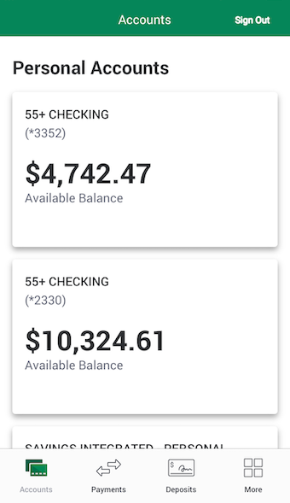 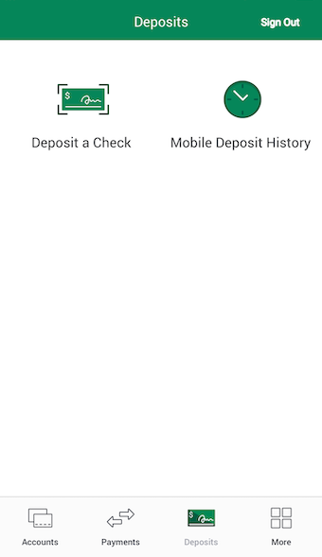

MDMainPage.jpg MDAccountSelection.jpg

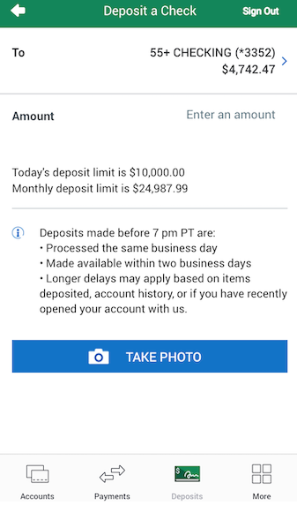 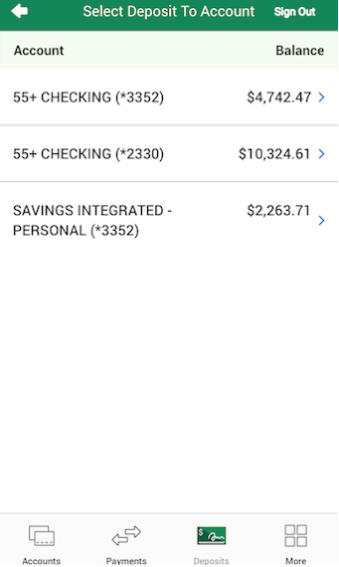

MDMainPage2.jpg

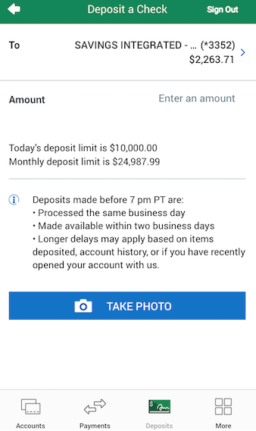

Start completing your templates on the next page.

# Your Demo

### Start drafting your Demo here!

|  |  |
| --- | --- |
| **Step Info** | |
| **Item** | **Your Info** |
| **Step Title** |  |
| **Complexity**How difficult is this step on a scale of 1-5? |  |
| **How many minutes will the step take to complete?** |  |
| **Description** What are people getting themselves into?!?! |  |
| **What players will learn** |  |
| **Does this contribute to learner progress?** |  |
| **Skills** |  |

|  |  |
| --- | --- |
| **Demo Goal**  (not seen by learners) |  |

## 

## Screen 1 -

|  |  |
| --- | --- |
| **Image File** |  |

|  |  |
| --- | --- |
| **Hotspot(s)**  (min. 1 required) |  |
| **Directs To** |  |
| **Guiding Text**  (seen in Guided Practice mode) |  |
| **Autotext**  (if applicable) |  |
| **Learn More Link Text**  (optional) |  |
| **Learn More Description**  (optional) |  |

*Copy and paste more Screen templates as needed.*

|  |
| --- |
| **Exit Summary Text** |
|  |

|  |  |
| --- | --- |
| **Completion Action** | |
| **Link Text** |  |
| **Link URL** |  |
| **Action Description** |  |
| **Image**  (include in separate folder) |  |